

Friday (is a f**king day!)

Check In #1
Time: 3–7 pm

(19–21 August)
Hash Hotel = Copper Queen


Location: The Hash Hotel pool area (2nd floor)
Bring: A thirst for beer.

Pay-as-you-go
Time: 8 pm
Location: Front of the Hash Hotel

Bring: Your take on lingerie meets luau! Money, ID, and a thirst for libations. Hula contest, karaoke, and fun to ensue!

Saturday (is a hashing day!)
Huachuca H3 Hash No. 1904 (Recommend Carpooling)
Time: 8 am
Location: Warren Ballpark – 99 Arizona St #73, Bisbee, AZ 85603. (Also Saturday morning Farmer’s Market)
Hares: NNSteve & Trihorsacocks

Bring: $4 (per person) or $5 (per family), your whistle, whatever hangover you acquired, and a thirst for beer to rid yourself of said hangover.

The Unsponsored Beer Mile of Bisbee 2022
Time: Cans crack High Noon, so get there before! (recommend 11:30 for r*nners to sign in)
Location: Casa de Candyman y Candy Ass (address & map on reverse).
Hare: Gung HO for chalk talk. Although rolling solo, our announcer NoG’nads will reprise his role as sportscaster!
Bring: 4 cans of beer, water, and whatever else you want to drink before or after the beer mile!

Check In #2
Time: 1:30–2:30 pm
Location: The Hash Hotel (poolside)

2022 Howlin’ H3 Red Dress Run
Time: 3:30 pm
Location: Front of the Hash Hotel (Group pic will be taken ON TRAIL)
Hares: Fast F%^&*er Eagle/Bisbee Ball Buster (B3), Only Half There (RDR/Turkey), Sir Pissalot (walkers).
Bring: You in a red dress, wearing your wrist band, a thirst for fun and beer,~$5 if you want a shuttle ride from the end back to the hash hotel.
Sunday (is a day of rest… F**K Sunday!)

Tombstone Hangover Hash
Time: 11 am until we can’t move anymore.
Location: Tombstone Medigovich Field (where North 7th St. and N. Cactus Dr. intersect with North St. (31.717512,
-110.060989) Next to the Walter J. Meyer Elementary School.

Hares: Filipenist and Jack Off All Trades
Bring: A thirst for beer, and $5 per person if you’re not a RDRer. Kill the kegs!!

Hash Hotel: 11 Howell Ave
Huachuca H3, Point A: Warren Ballfield 99 AZ St. From hash hotel: 8 min (3.4 miles)
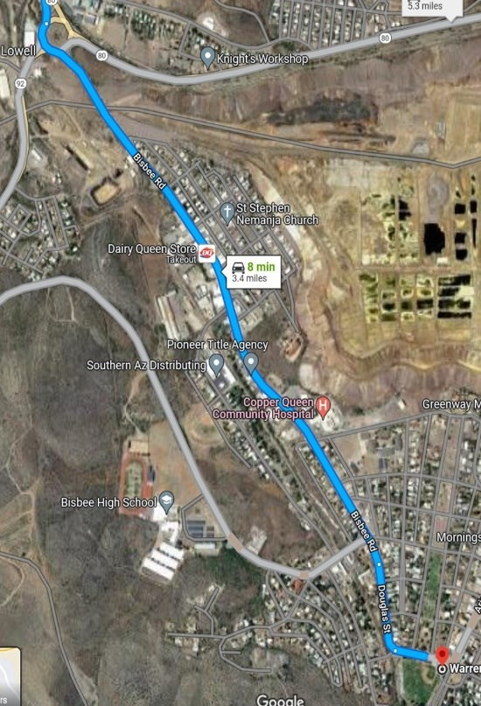Follow signs for AZ-80 E and merge (1.6 mi). At the traffic circle, take the 2nd exit onto Bisbee Rd (1.3 mi), Continue onto Douglas St, then Ruppe Ave
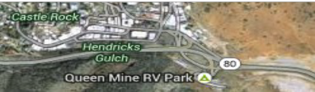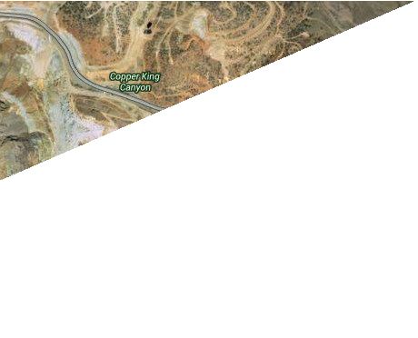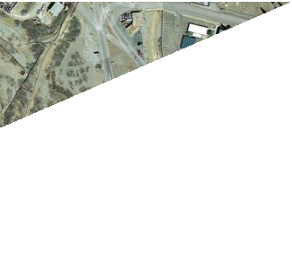

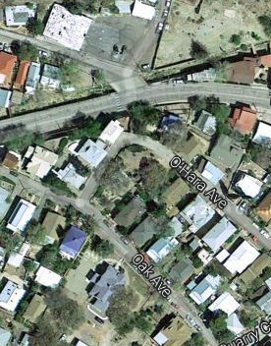Beer Mile: GPS: 319 O’Hara Ave, Bisbee, 85603

Stairs
Hangover Hash (Tombstone): Search for “Walter J. Meyer Elementary School” or (if using Google) “Apache ATV Tours,
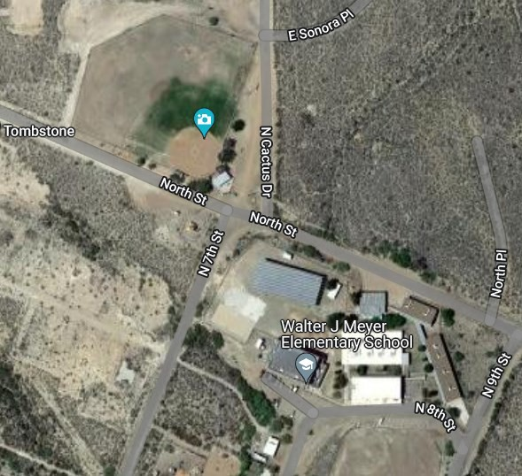Tombstone, AZ 85638” From hash hotel: Merge onto AZ-80 W (23 min/23.4 mi). Follow N Camino San Rafael and North St to N Cactus Dr (2 min/0.7 mi).

